1. The execution on the organization structure model is great but requires a little adjustment:
The first level is very needed before the chronology can work. So 17. Supervisory size is level 1 and they should be able to pick from which ever staff number method determination (Plain estimation, Factored estimation or work sample method) and the number of management staff result obtained at this level is now needed to determine the number of management staff for the next level. With your implementation, the K* determined at the second level is used to divide the number of management staff result obtained at level 1 to find the new number of management staff for level 2. (As it is now the number of staff at the various other level is not yet being determined). So, the number of management staff obtained now in level 2 is now needed as the numerator for the next level 3 divided by its obtained K* to now determine the number of management staff needed at this new level 3 etc. So, it shouldn’t be until K* gets to one that the save structure button gets activated and the iteration stops but when the number of management staff determined at any level becomes 1. Note please the number of management staff determined must be an integer and not real or double number type.
2. This percentage redundancy that show in the organization structure page ought not to be here
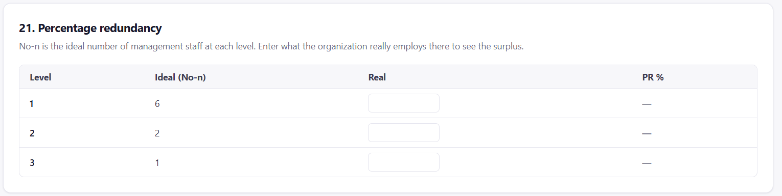
It should be with the redundancy Index model under the supervision cost page. Also together with the result 21. Percentage Redundancy (PR%) stored in the history page below when you click on view history
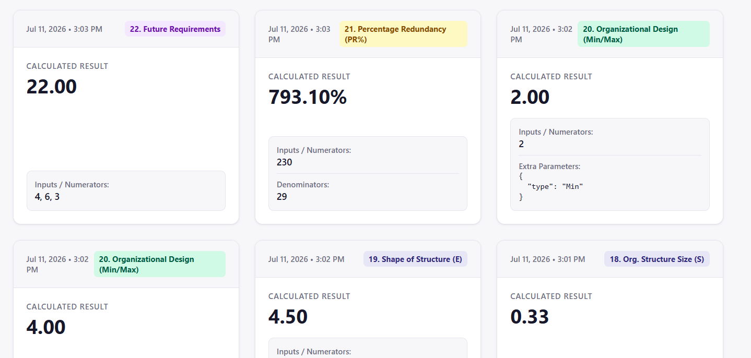
It should be at the view history page with the redundancy Index model under the supervision cost page.
Please note that what we have as shown presently with the supervision cost page under the redundancy index model, should be structure to be like what we have in that of the organization structure
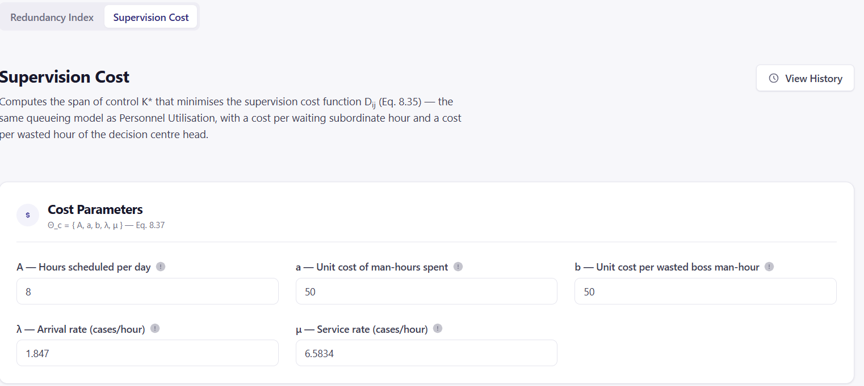
The only deference between the two is that while that of the organization structure is using the H* (which is a maximization optimization model) to determine the K* used, the redundancy index is using the D* * (which is a minimization optimization model) to determine its K* and its history page should look exactly like what we have in that of the organization structure.
3. The future requirements model you actualize is perfect.
4. Have you implemented and tested the motivational model?
5. Please, I will want you to help provide data into all data entry field and pages of the maintenance model for me to ascertain the workability of the model though myself and the last developer spent enough time on it but I haven’t been able to verify the complete job he implemented.

NOW TO YOUR DOCUMENT SENT
The nine items done
- Appraisal for companies and public/civil organizations: What is on place is fine.
- Maintenance Model back in pricing: Great and beautiful
- $λ≥μ$ must be refused: well executed
- Utilization history: Remove button, and H*/K* pulled from it: Well done, but I have provided more insight to what is still lacking above this section in item number 1 & 2.
- Supervision cost history: remove button, and D* pulled from it: Great, more insight into it is provided in item # 2 above this section
- Redundancy history to record D*, K*, $λ \& μ$: Well executed, Moore insight provided in iten # 2 in the section above
- Productivity history to record un-inflated output and input: Well executed.
- New future requirements model: Beautifully executed.
- Organization structure cascade: More insight provided in item # 1 above this section to completed the phase of execution

2. The execution button in each level: I have provided more insight into this above however, please note that the execution button is only to be assessed by the organization admin. The production/Industrial engineer to use these models should only have access to the saved button.
3. a) There are three determinants there and these are i) academic staff number including – Total number of students, Total no of academic staff, total number of non-academic staff, K*, $λ and μ$ ii) The number of staff in an organization (H*, K*, Total No of staff-including - supervisory staff, and management staff, $λ and μ$) iii) productivity cost prediction as found in the model history page.
And you are right that if pairing must come from the utilization history itself (which it should), those runs will need the staff numbers stored alongside them.
b) The real head counts should come from the employee record and which should cover the management level.
4. a) Thanks for including the r2 indices but however we must let them know how to understand its meaning and result obtained. AI will suggest that a minimum of three scattered point data is what is needed for the best fit line to make more meaning. And please do let them know the implication of removing or using the remove button on any history data already saved
b) The full utilization page can be made available only at the determination of the number of management staff at level one based on the store value of its utilization once selected ever every other variable remains constant except the $λ, and μ$ data that are newly supplied at each section that varies.

